Here are the details for the final race of the 2025/2026 league season for Division 2 ladies and Division 3 men.
Attached is the course map for both races and location of additional parking on local roads
Taking place on Saturday 7th Febuary 2026 at,
Coombe Abbey Country Park , Brinklow road ,Binley , Warwickshire
Sat Nav Post code : CV3 2AB

Ladies Race Starts at 10AM / Men's race starts at 11AM
Both start times cannot be delayed

Ladies 6KM ( 2 Short laps followed by 1 Long lap)
Men 10km Mile (2 short laps followed by 2 Long Laps )

Club tents to be set up on the event field directly in front of the visitor centre next to the start line, which is a short walk from the carpark.
No warming up or cooling down on the course once ladies race stars

Carparking :- Please read carefully and inform your athletes

It is very Important to fully car share as much as possible into the venue, there is a real possibility you will not be able to get a space in the venue.
We do not have only access to the venue on the day as its still open to the general public.
Please also allow plenty of time to get through the ANPR barrier entry to the car park . As this does form a long queue into the venue.
There is some additional parking located on Valencia Road CV32AF
what3words = Spider.tall.backed
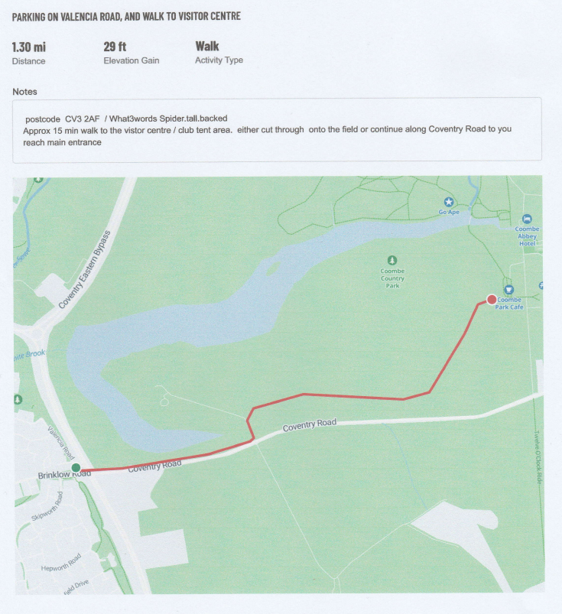
If Parking in residential streets which will not be marshalled please park with care and consideration for residents and do not block any driveways.
From here there is approximately a 15/20min walk along Coventry road to the visitor centre and club tent area
(see attached map)
Failure to do this will result in a loss of use of the venue for any future league races.
On arrival at the venue continue down main driveway and turn right into the main carpark. We do not have sole use of the carpark as the venue is still open to the general public. It is your responsibility to arrive with enough time to park and get to the tent area in front of the visitor centre before your race starts .

The carpark is ANPR barrier monitored . Which you have to pay at the machine (cashless) when you leave.
No Carparking is permitted along the Brinklow road leading to the venue . This will be monitored and vehicles are at risk of fines or even towed away
Minibuses are ok however coaches are not allowed .
All cars are parked at the owners risk and the event organisers do not accept liability to any possible damage or theft caused to vehicles during the event
Travel directions to the venue:-
Coombe Abbey Country Park , Brinklow road ,Binley , Warwickshire
Sat Nav Post code : CV3 2AB
From Birmingham exit M6 Junction 2
Keep right up the slip road following signs for A46 / Coventry, At Ansty interchange take 3rd exit onto Coventry eastern bypass (A46)
Continue under bridge , slight right to stay on Eastern bypass ,
Merge onto Coventry Eastern bypass , at 1st roundabout take 1st exit A46
Exit next junction A428 Coventry East and Cen
Turn Right onto Brandon road
Continue straight over 2 roundabouts
Turn right at traffic lights by Toby Carvery
Turn right at next lights continuing on Brinklow road B40227 ( Brown Coombe Abbey Sign )
Continue along Brinklow Road for approx. 1.5 mile then turn left at main entrance to Coombe hotel/ Country park
From Leicester M69/A5
Continue on M69 which becomes the Coventry Eastern bypass , at 1st roundabout take 1st exit staying on A46
Exit next junction A428 Coventry East and Cen
Turn Right onto Brandon road
Continue straight over 2 roundabouts
Turn right at traffic lights by Toby Carvery
Turn right at next lights continuing on Brinklow road B40227 ( Brown Coombe Abbey Sign )
Continue along Brinklow Road for approx. 1.5 mile then turn left at main entrance to Coombe hotel/ Country park
From A45 /A46 Stivichall Interchange
Continue along A45 (Stonebridge highway ), at approach to Tollbar island stay in right hand lane, and continue under the traffic island , this then becomes Coventry eastern bypass (A46) ,
Continue along eastern bypass ,
Exit at next Junction (A428 Brandon Road )
At Junction turn Left onto A428
Continue Straight over next 2 roundabouts
Turn Right at traffic lights by Toby Carvery onto Brandon Road
Turn next Right at lights onto Brinklow Road ( Brown Coombe Abbey Sign )
Continue along Brinklow road for approx. 1.5 mile then turn left at main entrance to Coombe abbey hotel/ country park
Race registration for both leagues will be just inside the visitor centre past the café entrance .
Toilets are located at the side of the visitor centre .
The Presentation to take place in front of the visitor centre after the completion of the men’s race .
The Cafe will be open and is cashless.
The Ladies course is a 3 lap course made up of 2 short lap Followed by 1 large lap .
The Men’s course is a 4 lap course made up of 2 short lap Followed by 2 long laps.
Ladies Race starts at 10AM and Men’s Race starts at 11AM

Both races start and finish in front of the visitor centre parallel to the main driveway, continuing alongside the main drive till you reach the first turn at the end of the driveway ( approx 350m ) then follow the perimeter of the park around till you get to the 1st gate which will be marshalled. Taking a left turn at the gate brings you onto the start of the short lap, For Men complete this 2 times before heading onto the 2 larger Laps when you get back to the gate at the end of the 4th lap . Turn Left and follow course directions to the finish line.

For Ladies after completing 2 short laps continue on to 1 large lap then following directions to the finish.
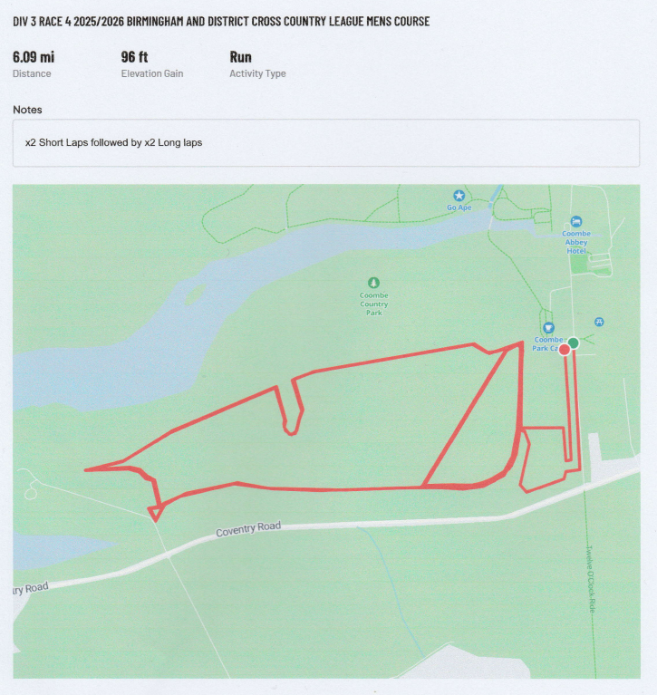
The course is all on grass spikes and trail shoes are recommended.
Have a good race
Sphinx AC and Northbrook AC

